**PROJECT 1**

**ALU DESIGN**

**Tran Tue Nhi**

**COMP1020 - CECS**

***October 20th, 2021***

# Overview: RISC-V ALU

In this project, I designed a 32-bit ALU which consists of 4 parts: Add, CompareOp, Shift and LogicOp operation.

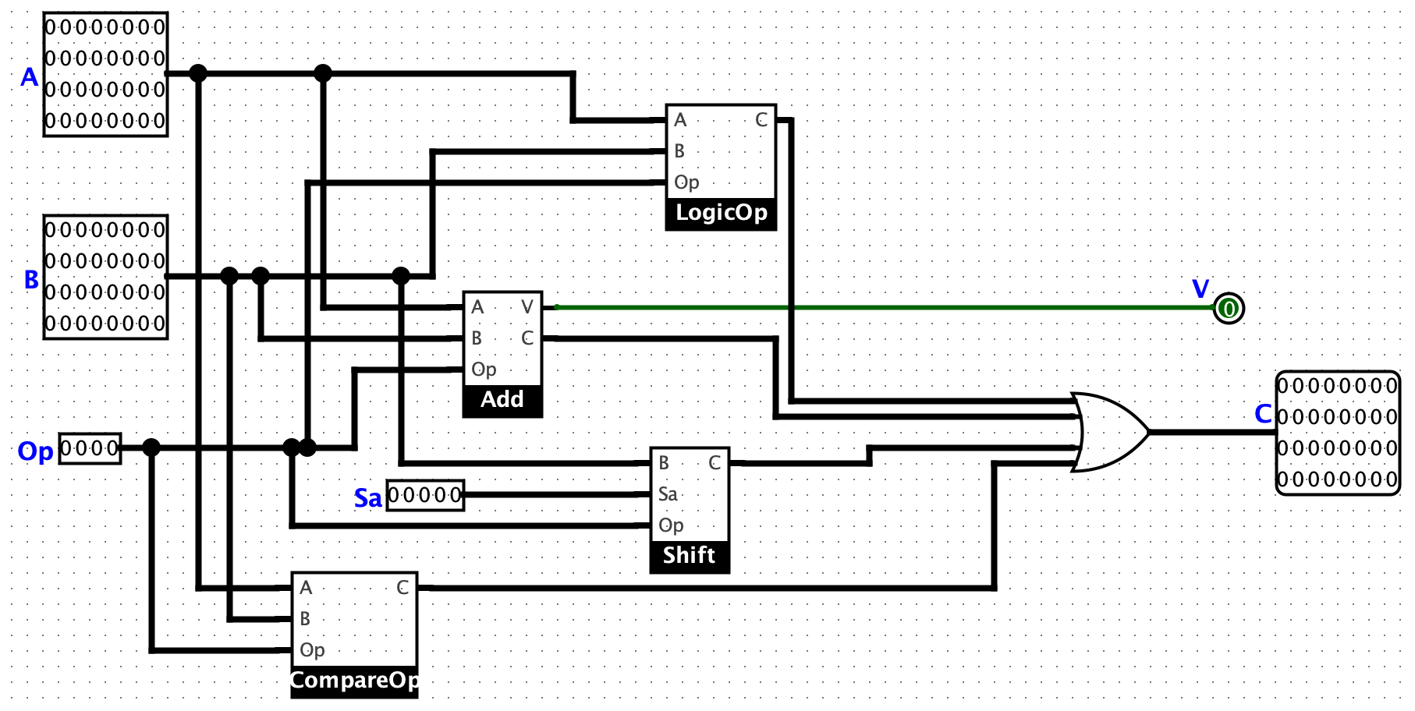

## 32-Bit ALU

1. **Circuit 1: RISC-V ALU**

* **There are 4 sub-circuits in the circuit LeftShift32:** Add, CompareOp, LogicOp and Shift.
* Sub-circuit Add:

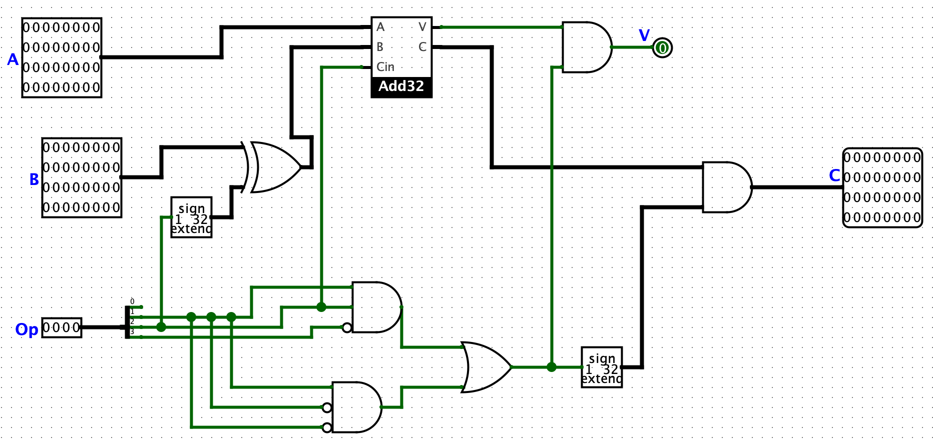

* Sub-circuit CompareOp:

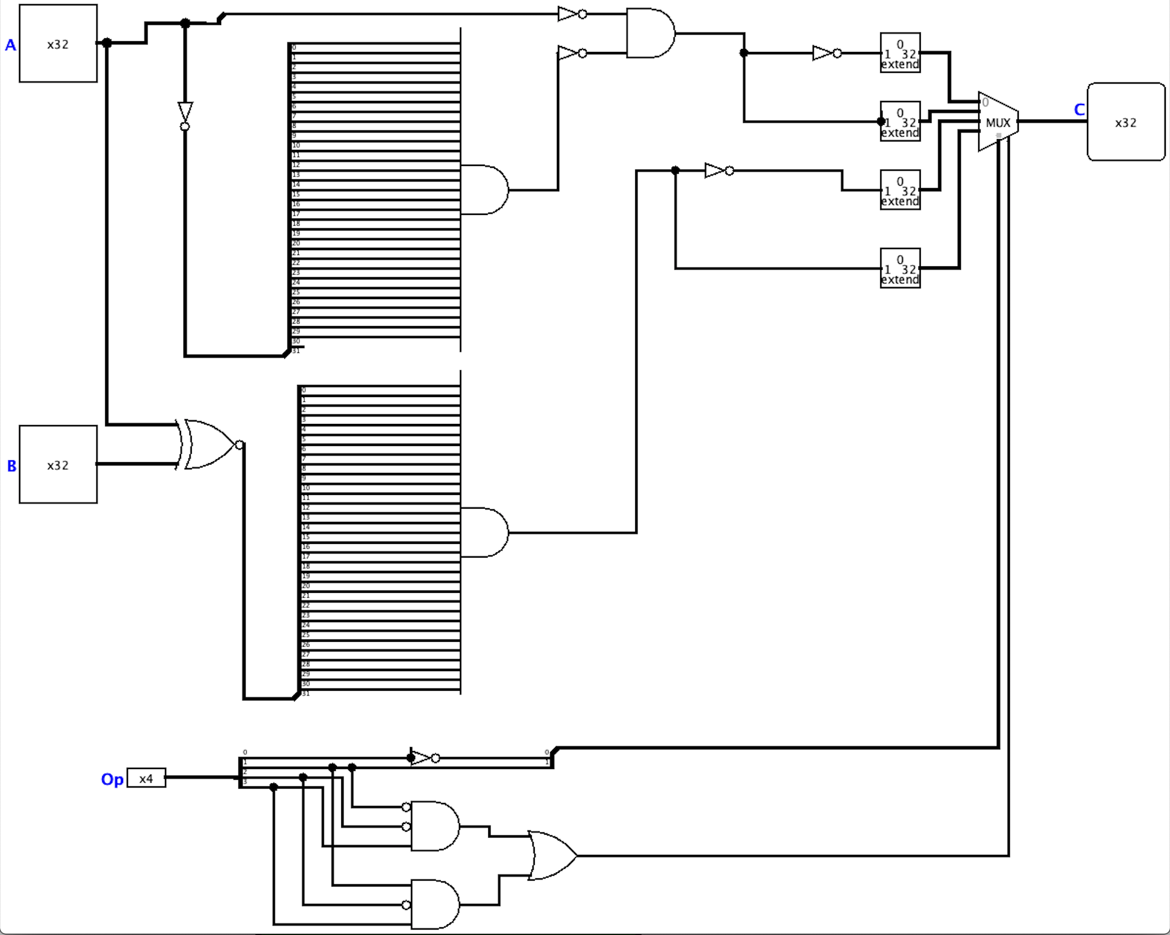

* Sub-circuit LogicOp:

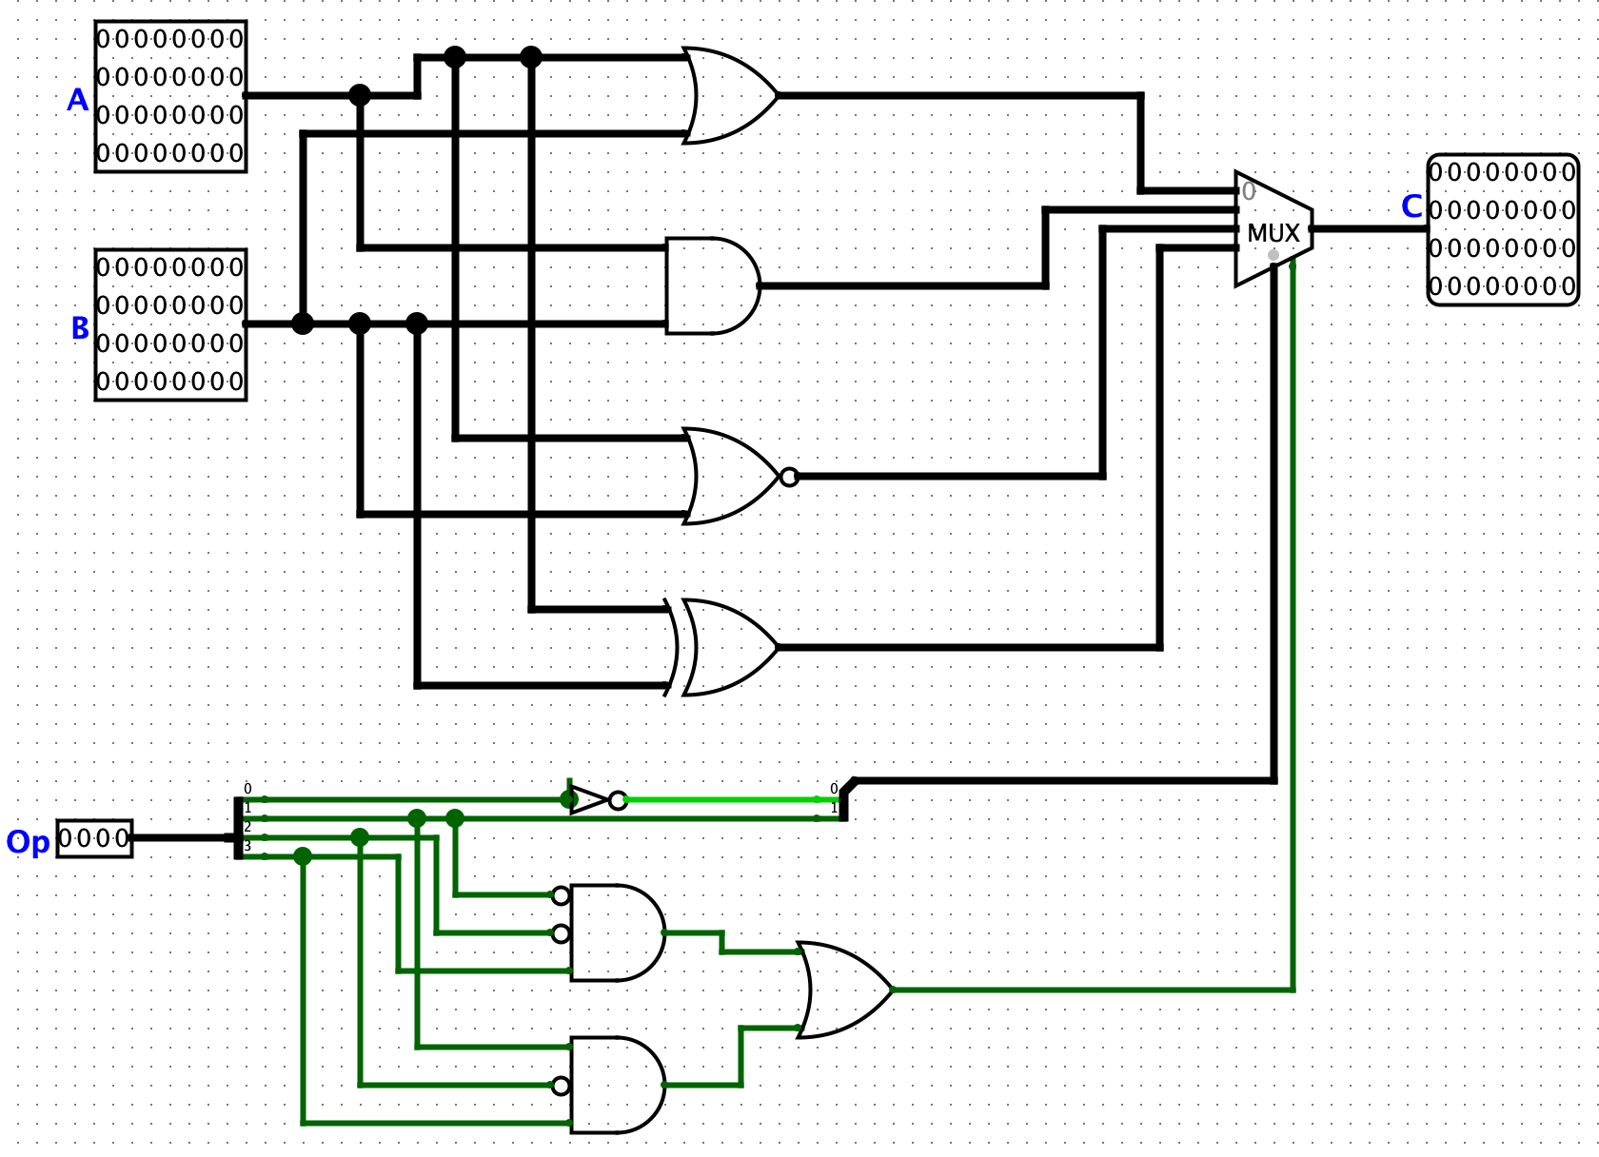

* Sub-circuit Shift:

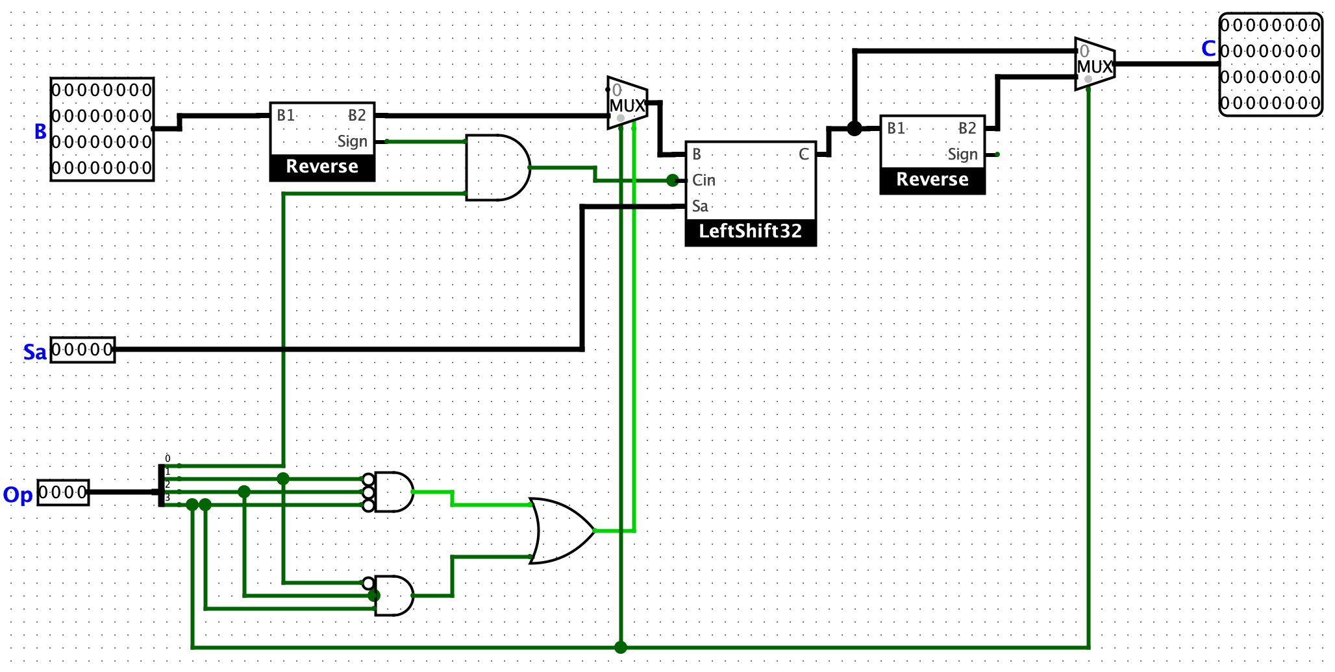

# Circuit 1: LeftShift32

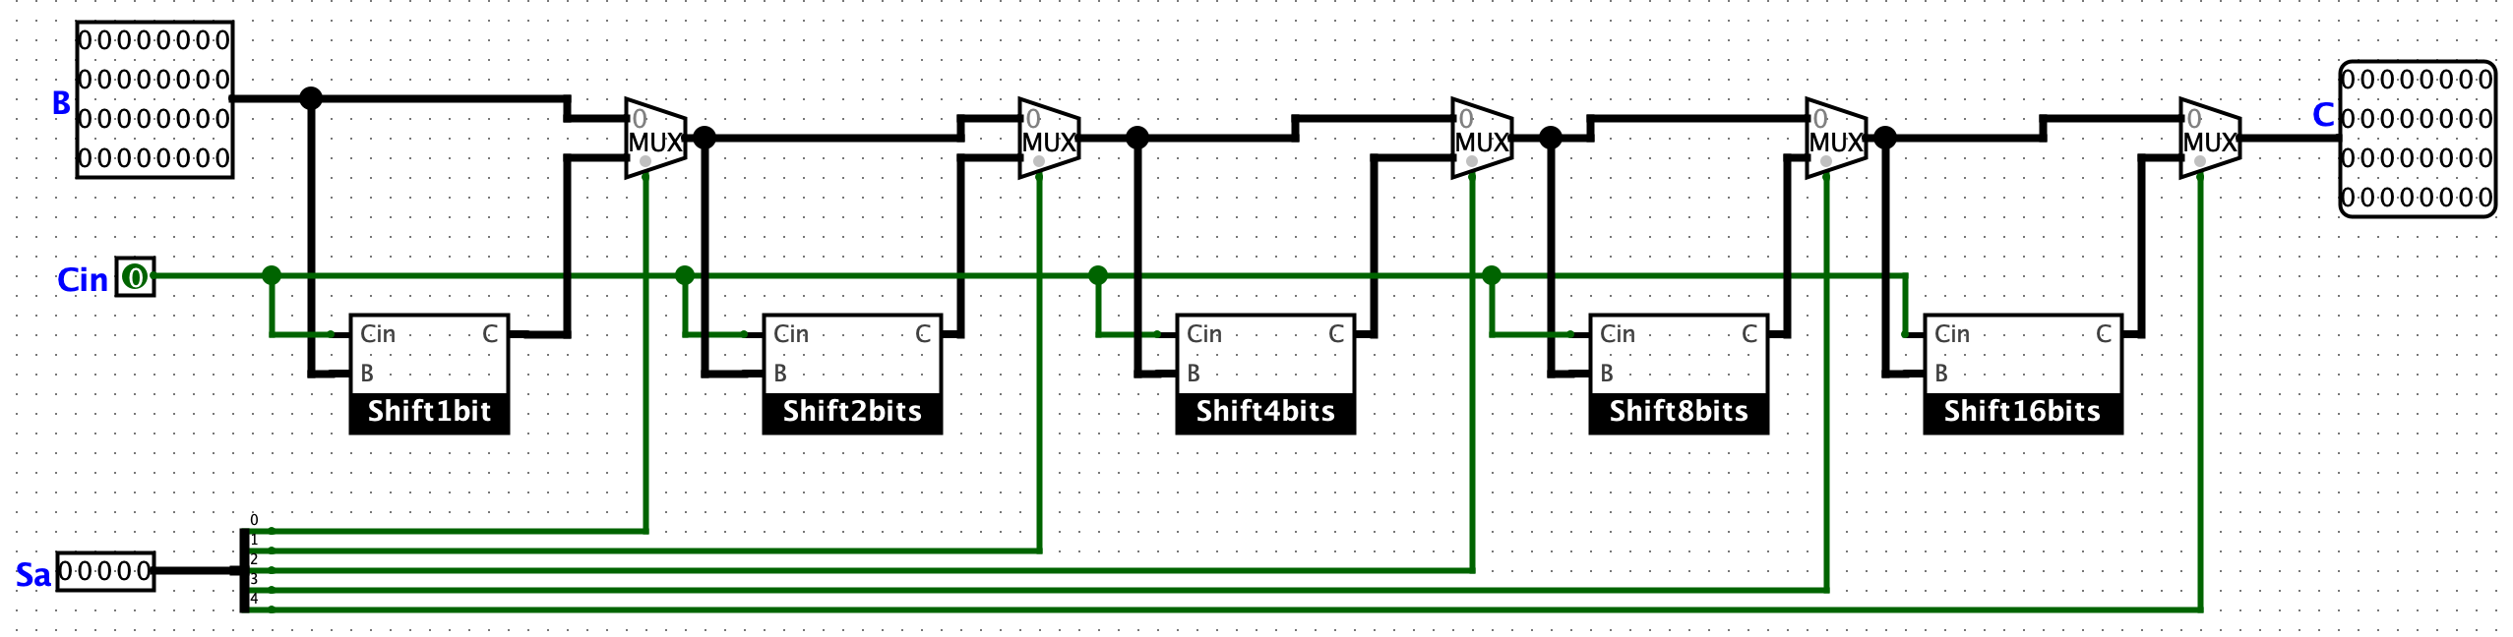

## Circuit LeftShift32

* **There are 5 sub-circuits in the circuit LeftShift32:** Shift1bit, Shift2bits, Shift4bits, Shift8bits and Shift16bits.
* Sub-circuit Shift1bit:

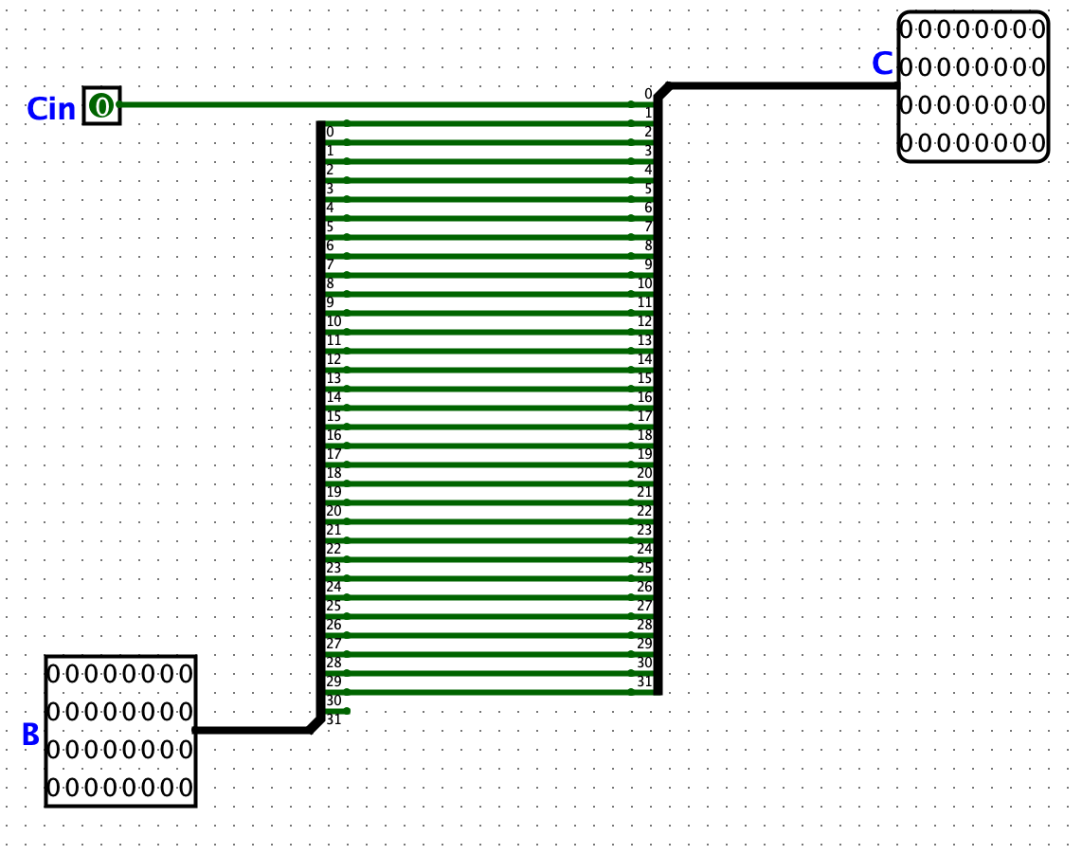

* Sub-circuit Shift2bits:

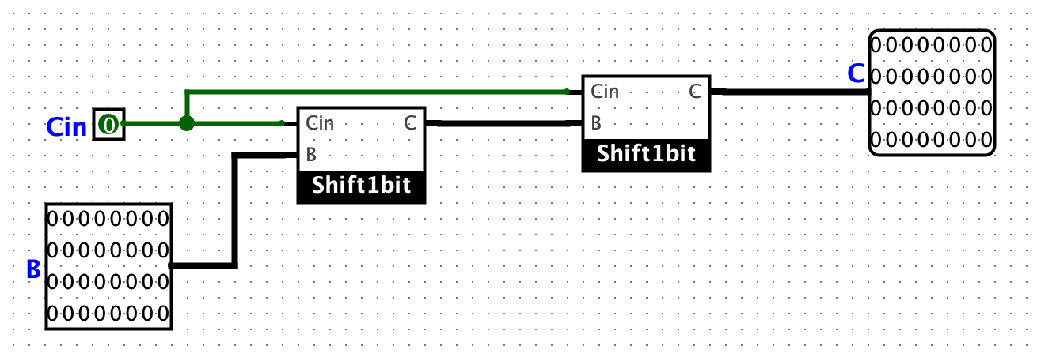

* Sub-circuit Shift4bits:

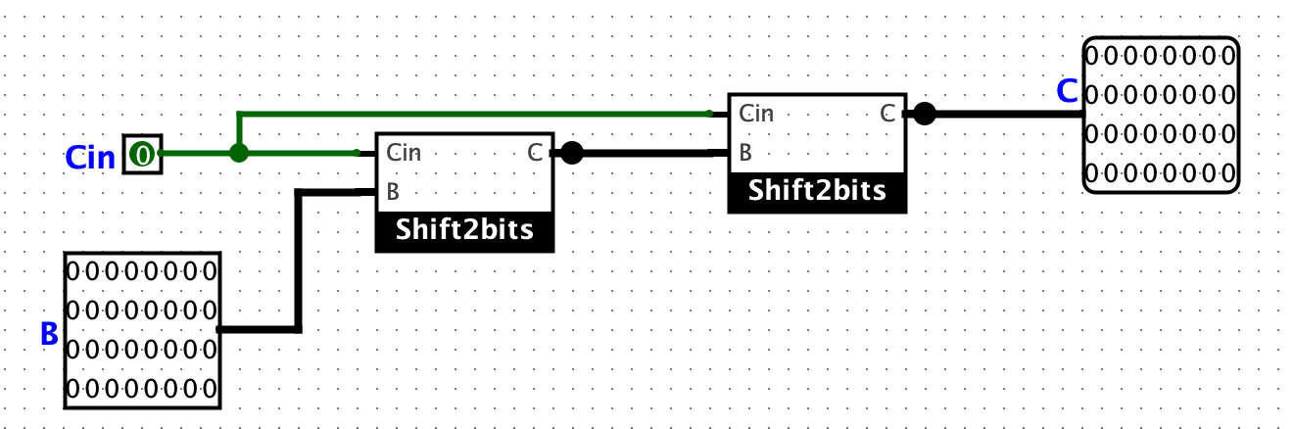

* Sub-circuit Shift8bits:

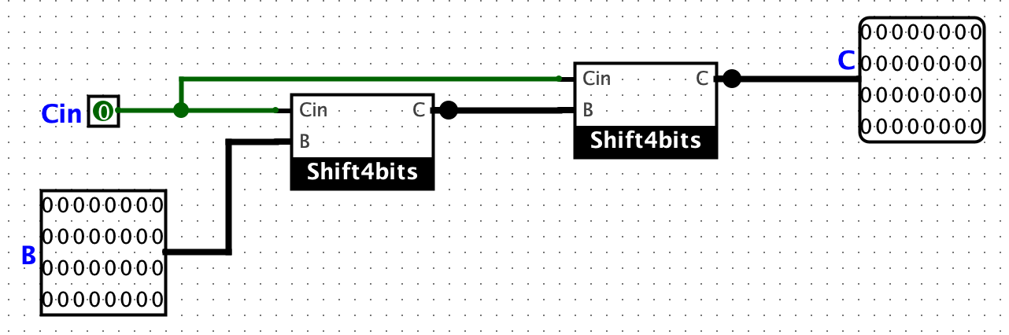

* Sub-circuit Shift16bits:

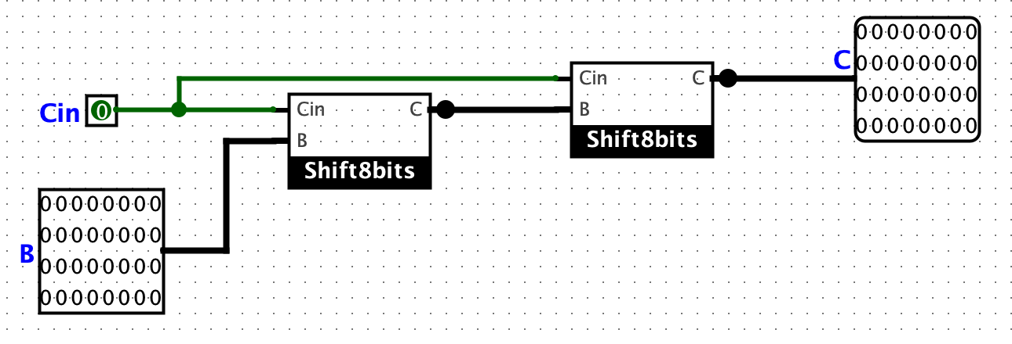

# Circuit 2: Add32

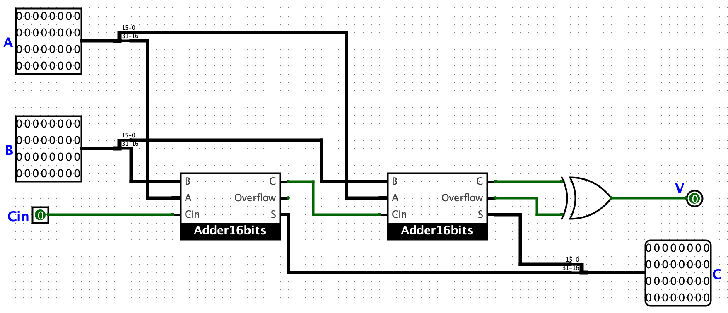

## Circuit Add32

* **There are 3 sub-circuits in the circuit Add32:** Add1bit, Add2bits, Add4bits, Add8bits and Add16bits.
* Sub-circuit Adder1bit:

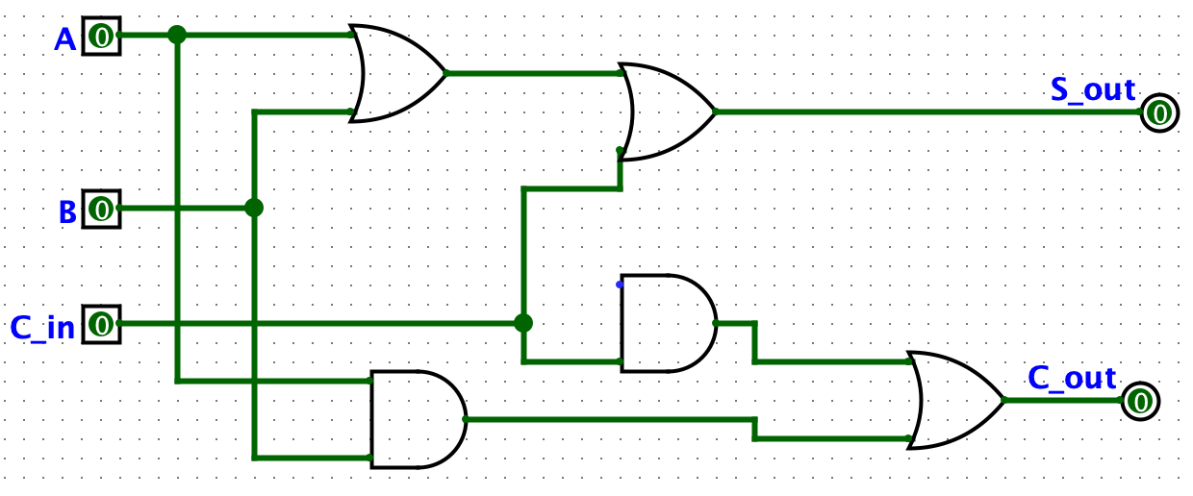

* Sub-circuit Adder4bits:

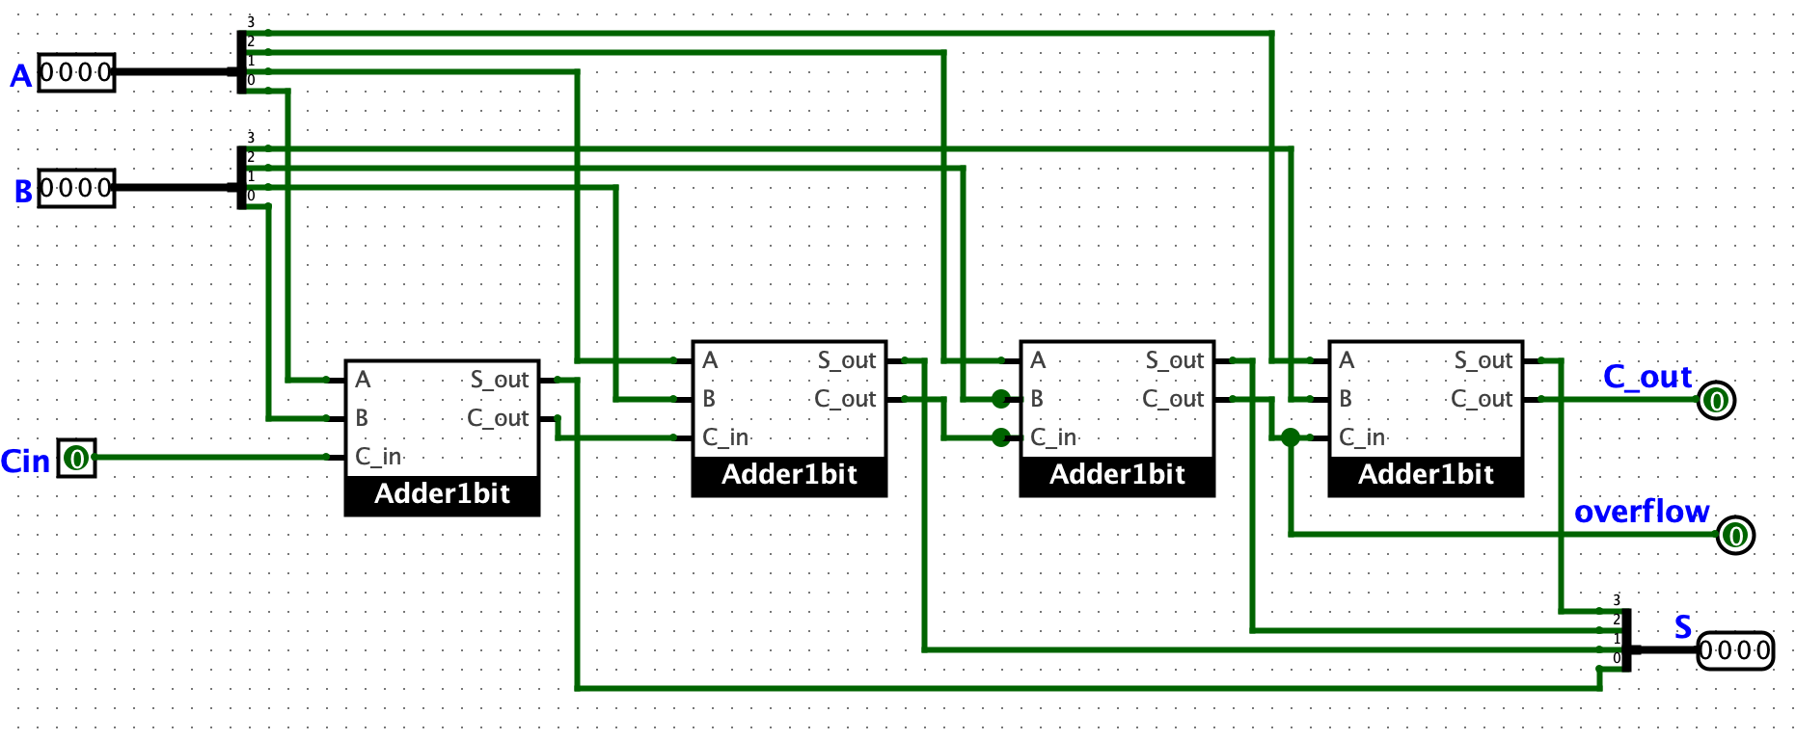

* Sub-circuit Adder16bit

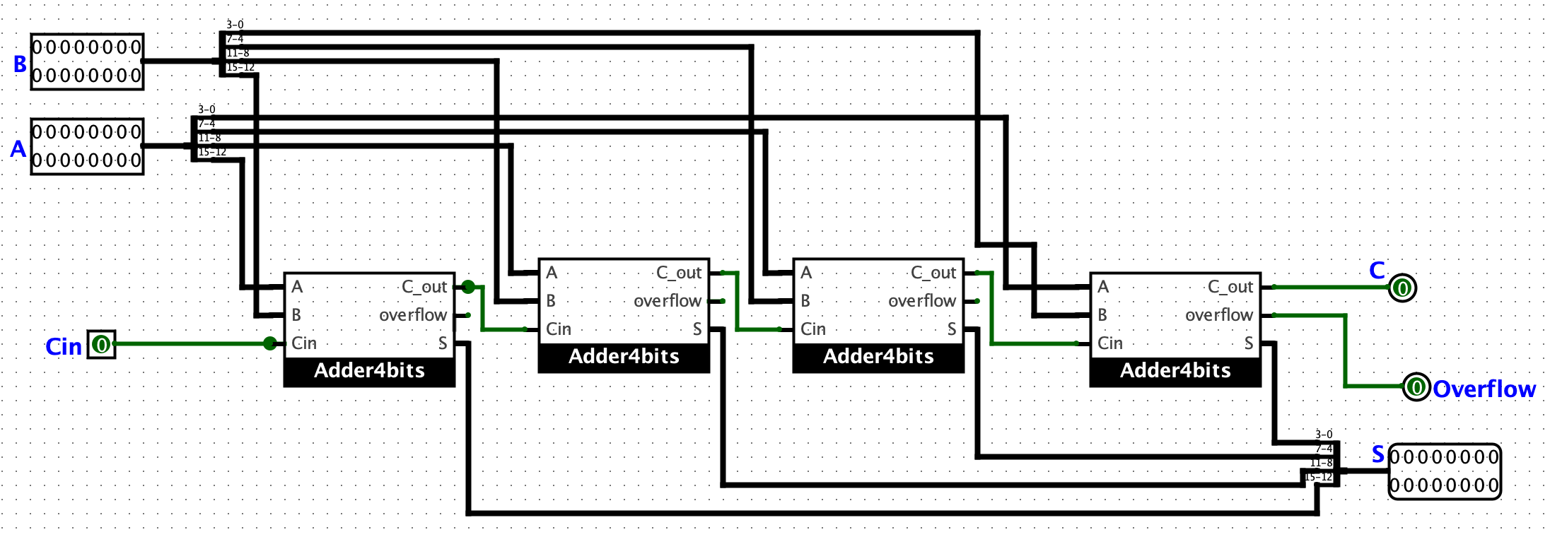

*Thank you for reading!*